Recognize your members who have recruited new members for your club. This crosses administrations and you may go back as far as 2000 to “catch-up” and honor your members.
HOW IT WORKS: Start with 2000 and build a chart similar to the one on the back of this flier for each current member. Note the new members she has brought to the club and are still dues paying members.
SEND TO MONTANA’S MEMBERSHIP CHAIRMAN: Submit the completed sheet for any member who has brought in five (5) new dues paying members.
DUE DATES: August 1st and January 1st so stars may be verified, ordered, and presented at Fall Board, your District Convention, or our Biennial Convention.
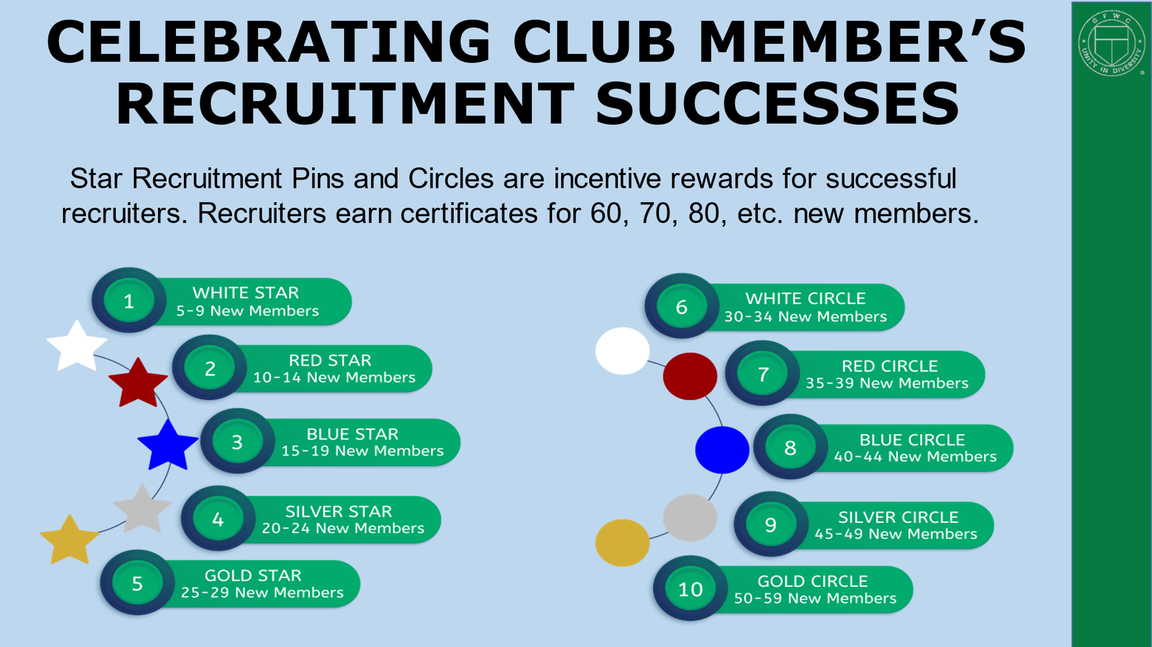

CELEBRATE YOUR “STAR” RECRUITERS
CLUB: _______________________________________________________________

CONTACT PERSON: _________________________________ PHONE NUMBER: ____________________________________

MEMBER TO BE RECOGNIZED: ___________________________________________

COMPLETE ONE SHEET FOR EVERY FIVE MEMBERS RECRUITED AND WHO REMAIN DUES PAYING MEMBERS. SUBMIT THE FORMS TO:
Karen Gustavsen, GFWC Montana Membership Chairman, PO Box 876, Thompson Falls, MT 59873 Have a question? Call 406-827-9480

NEW MEMBER’S NAME | NEW MEMBER’S ADDRESS | DATE JOINED

STAR LEVEL ACHIEVED: (CIRCLE ONE) 5 MEMBERS – WHITE 10 MEMBERS – RED
15 MEMBERS – BLUE 20 MEMBERS – SILVER 25 MEMBERS – GOLD

CIRCLE LEVEL ACHIEVED: (CIRCLE ONE) 30 MEMBERS – WHITE 35 MEMBERS – RED

40 MEMBERS – BLUE 45 MEMBERS – SILVER 50 MEMBERS - GOLD

